Auto Ticket Classification using Flow Designer
Project Report

Team ID | SWTID-2026-7310
Team Size | 5
Team Leader | Mohan Kumar S
Team Member | Muhammed Ibrahim A
Team Member | Ponakilan J
Team Member | Pradeep B
Team Member | Ragulprathap R

Contents
1. Introduction
2. Ideation Phase
3. Requirement Analysis
4. Project Design
5. Project Planning & Scheduling
6. Functional and Performance Testing
7. Results
8. Advantages & Disadvantages
9. Conclusion
10. Future Scope
11. Appendix

1. Introduction

1.1 Project Overview
The school IT helpdesk receives many incident requests every day from students and teachers: Wi-Fi issues, projector failures, password problems and slow computers. IT staff currently review each request and assign a category, which is time-consuming and inefficient.
This project automates ticket classification with ServiceNow Flow Designer. When a ticket is created, the flow analyses keywords in the Short description, sets Category and Subcategory automatically and sends a confirmation email to the caller. Tickets are stored in a custom table with dependent choice fields, and the whole solution is no-code and easy to maintain.

1.2 Purpose
- Automatically classify incidents at the time of creation.
- Reduce manual effort for IT agents.
- Improve ticket routing efficiency.
- Implement a no-code, easily maintainable solution.

2. Ideation Phase

2.1 Problem Statement
PS | I am (Customer) | I'm trying to | But | Because | Which makes me feel
PS-1 | A student / teacher raising an IT ticket | get my Wi-Fi, projector, password or slow-PC issue fixed quickly | tickets wait for manual categorisation or reach the wrong team | there is no automatic classification or acknowledgement | frustrated and worried about lost class time
PS-2 | An IT helpdesk staff member | classify every incident with the right category and subcategory | it is slow and error-prone as requests grow | every ticket is read and classified by hand | overloaded and unable to focus on resolving issues

2.2 Empathy Map Canvas
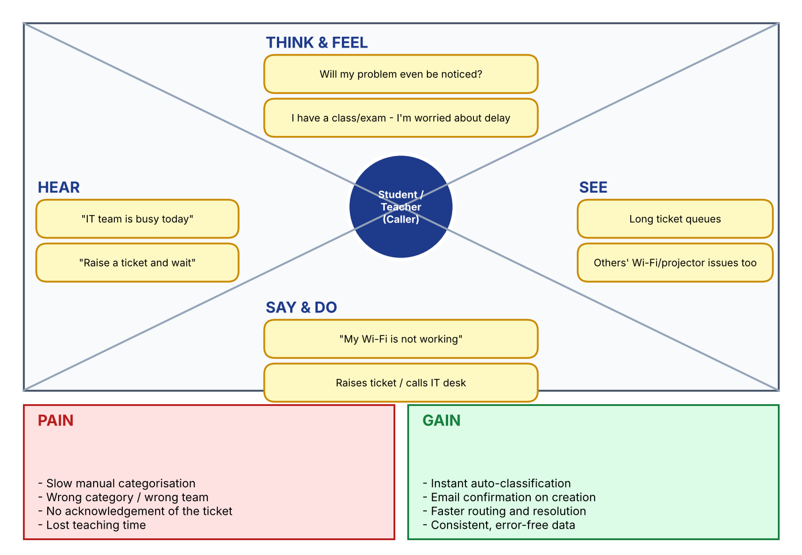

2.3 Brainstorming

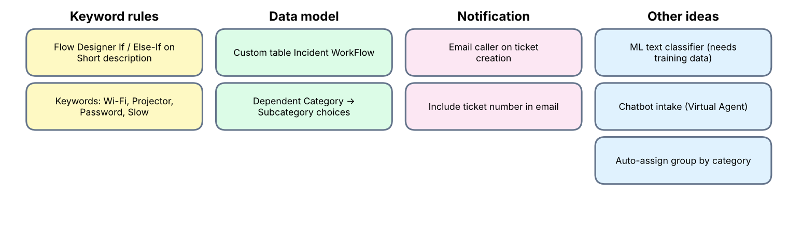
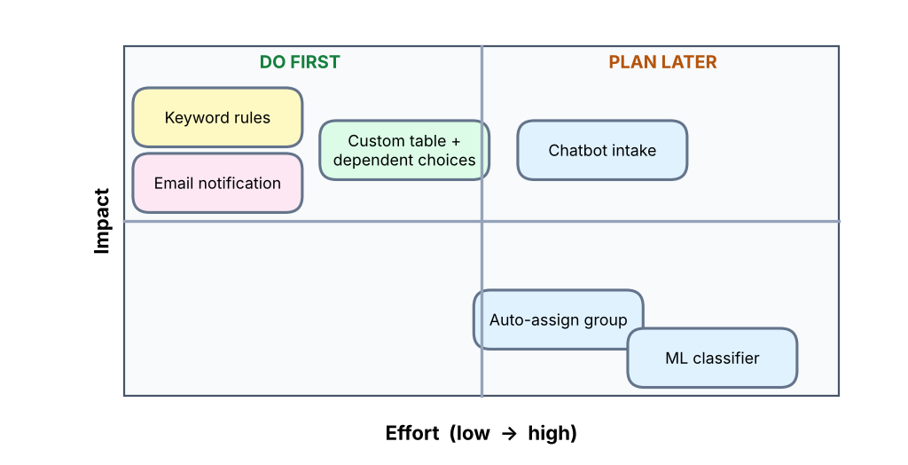
Selected ideas: keyword-based classification with Flow Designer, custom table with dependent choices and an automatic email to the caller. Automatic group assignment, an ML classifier and chatbot intake are kept for future scope.

3. Requirement Analysis

3.1 Customer Journey Map
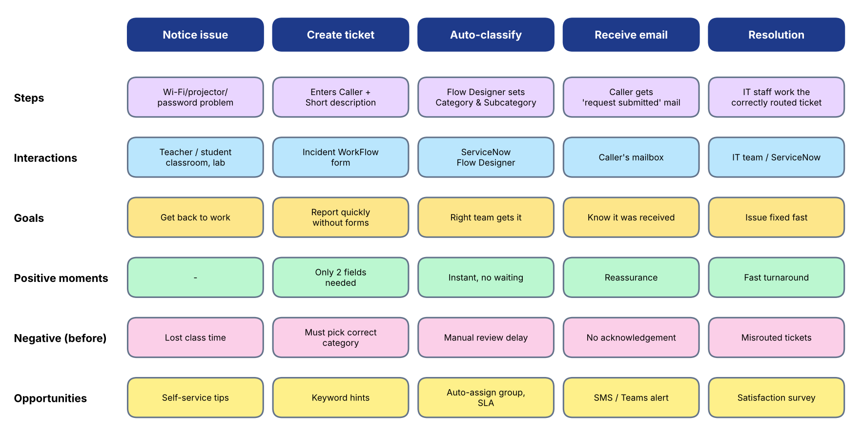

3.2 Solution Requirement
Functional requirements
FR No. | Functional Requirement (Epic) | Sub Requirement (Story / Sub-Task)
FR-1 | Ticket Creation | Caller creates a ticket entering Caller and Short description; ticket number generated automatically (INC prefix)
FR-2 | Automatic Classification | Flow triggers on record creation when Category is empty; keyword match sets Category and Subcategory (Network/Wi-Fi, Hardware/Projector, Access/Forgot Password, Performance/Slow Computer)
FR-3 | Category - Subcategory Dependency | Subcategory options change with the selected Category
FR-4 | Email Notification | Send Email action mails the caller after classification
FR-5 | Structured Data Storage | Custom table Incident WorkFlow (u_incident_workflow) with standard fields
FR-6 | Maintenance & Deployment | No-code flow; changes captured in Project Update Set and exported to XML

Non-functional requirements
NFR No. | Non-Functional Requirement | Description
NFR-1 | Usability | Caller enters only Caller and Short description; standard ServiceNow form
NFR-2 | Security | Access controls on the custom table; only authorised users modify tickets
NFR-3 | Reliability | Rule-based and deterministic: same keyword gives the same category
NFR-4 | Performance | Flow runs at record creation and completes within seconds
NFR-5 | Availability | Runs on the ServiceNow cloud platform
NFR-6 | Scalability | New keywords or categories added by configuration, no coding

3.3 Data Flow Diagram
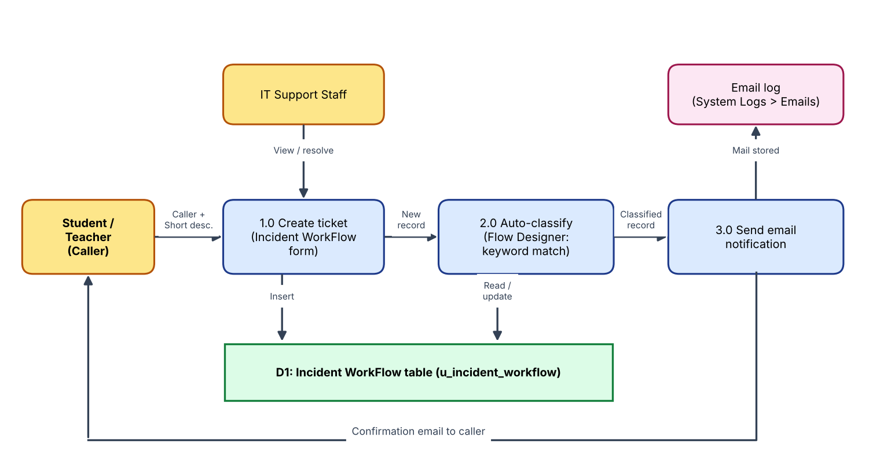
User stories
User Type | Epic | USN | User Story / Task | Priority | Release
Student / Teacher | Ticket Creation | USN-1 | Create an IT ticket by entering name and short description | High | Sprint-3
Student / Teacher | Automatic Classification | USN-2 | Ticket categorised automatically | High | Sprint-2
Student / Teacher | Email Notification | USN-3 | Receive an email confirming the request was submitted | High | Sprint-2
IT Support Agent | Ticket Handling | USN-4 | See classified tickets without manual triage | High | Sprint-2
IT Support Agent | Ticket Handling | USN-5 | Set State, Assigned group and Assigned to | Medium | Sprint-1
Administrator | Data Model | USN-6 | Create custom table with auto-numbering | High | Sprint-1
Administrator | Data Model | USN-7 | Define choice fields and dependent Category > Subcategory | High | Sprint-1
Administrator | Flow Automation | USN-8 | Maintain classification rules in Flow Designer without code | Medium | Sprint-2
Administrator | Deployment | USN-9 | Capture changes in an update set and export XML | Medium | Sprint-3
Administrator | Security | USN-10 | Restrict ticket data to authorised users | Medium | Sprint-3

3.4 Technology Stack
S.No | Component | Description | Technology
1 | User Interface | Incident WorkFlow form for callers and agents | ServiceNow UI / Form Designer
2 | Application Logic | Trigger, If / Else-If classification, Update Record, Send Email | ServiceNow Flow Designer (no-code)
3 | Database | Custom table u_incident_workflow with auto-number, choice and reference fields | ServiceNow platform database
4 | File Storage | Update set exported as XML | Local file system / Mail
5 | External API / ML model | Not used - rule-based keyword matching | -
6 | Infrastructure | Cloud deployment in Global application scope | ServiceNow cloud instance
7 | Security | Access control on the custom table (role u_incident_workflow_user) | ServiceNow ACLs / roles

4. Project Design

4.1 Problem Solution Fit
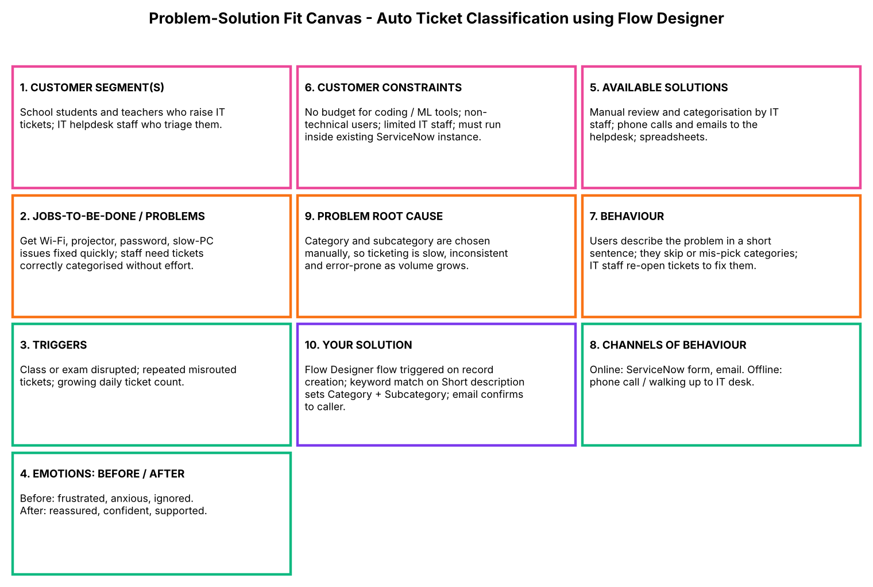

4.2 Proposed Solution
S.No. | Parameter | Description
1 | Problem Statement | Manual, slow and error-prone categorisation of daily school IT tickets
2 | Idea / Solution description | Flow Designer flow classifies tickets by Short description keywords, sets Category and Subcategory and emails the caller
3 | Novelty / Uniqueness | Fully no-code, rule-based, tailored to common school IT issues, with dependent choices and instant acknowledgement
4 | Social Impact / Customer Satisfaction | Faster support, less lost class time, instant reassurance, staff time freed for resolution
5 | Business Model (Revenue Model) | Internal service-improvement tool; value from saved staff hours; reusable as an update set
6 | Scalability of the Solution | New keywords and categories added by configuration; update set installs on other instances

4.3 Solution Architecture
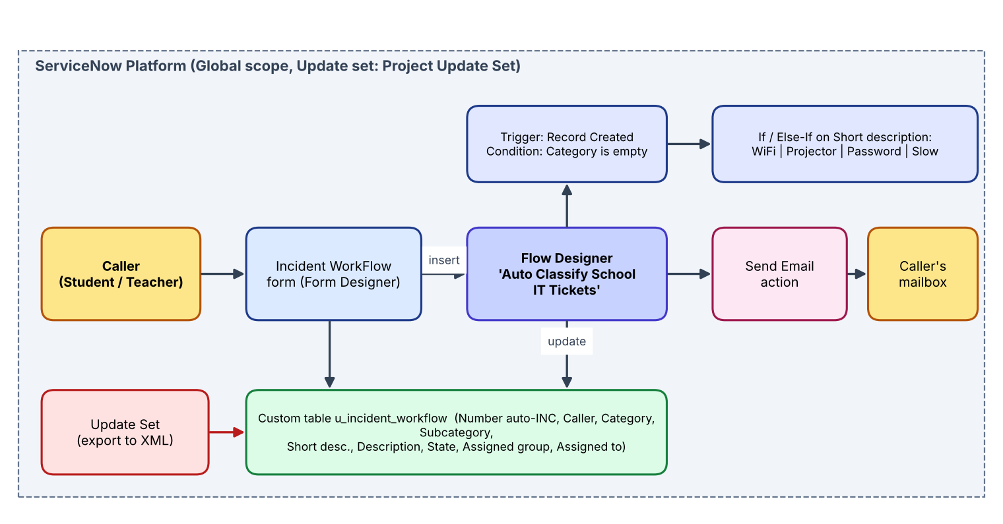
Figure: Architecture and data flow of the Auto Ticket Classification solution

5. Project Planning & Scheduling

5.1 Project Planning
Sprint | Epics / Work | Story Points | Duration | Start | End (Planned) | Completed | Release (Actual)
Sprint-1 | Environment setup, Data model (table, fields, choices, dependency) | 11 | 6 Days | 19 Jan 2026 | 24 Jan 2026 | 11 | 24 Jan 2026
Sprint-2 | Flow automation (trigger, 4 classification branches, email, activate) | 12 | 6 Days | 26 Jan 2026 | 31 Jan 2026 | 12 | 31 Jan 2026
Sprint-3 | Testing & validation, deployment (update set), documentation | 12 | 6 Days | 02 Feb 2026 | 07 Feb 2026 | 12 | 07 Feb 2026

Total story points = 35; velocity = 35 / 3 = 11.67 (about 12 story points per sprint); average velocity per day = 11.67 / 6 = about 1.94.
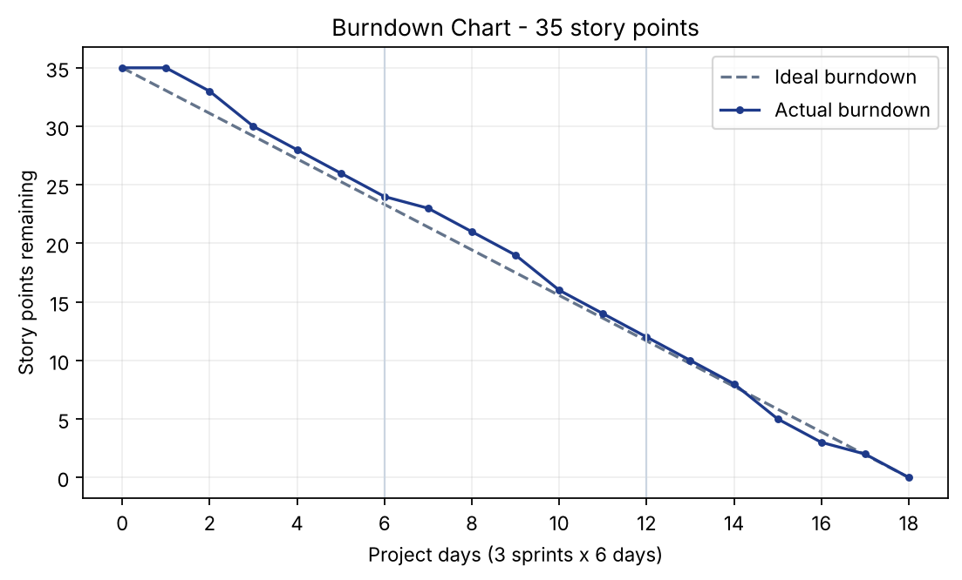
Burndown chart

6. Functional and Performance Testing

6.1 Performance Testing
The Flow Designer automation was tested end to end. Two classification scenarios (Network / Wi-Fi and Projector) were executed with 100% correct classification; the confirmation email was verified in System Logs > Emails; auto-numbers were generated without duplication (INC00511, INC00512).
ID | Scenario | Expected | Result
TC-001 | Auto-number generated for new tickets | Unique INC number generated (INC prefix) | Pass
TC-002 | Subcategory depends on Category | Network > Wi-Fi; Hardware > Projector; Access > Forgot Password; Performance > Slow Computer | Pass
TC-003 | Network / Wi-Fi ticket (Test Scenario 1) | Category = Network, Subcategory = Wi-Fi | Pass
TC-004 | Projector ticket (Test Scenario 2) | Category = Hardware, Subcategory = Projector | Pass
TC-005 | Password ticket | Category = Access, Subcategory = Forgot Password | Not tested
TC-006 | Slow computer ticket | Category = Performance, Subcategory = Slow Computer | Not tested
TC-007 | Confirmation email to caller | Email 'Your Request for the issue has been submitted.' sent to the caller's email | Pass
TC-008 | Only authorised users access ticket data | Access denied | Not tested
TC-009 | Update set completed and exported | XML file downloaded | Pass

Open observations from review:
Bug ID | Description | Severity | Status
BG-001 | Keyword 'WiFi' (no hyphen) is not matched: the flow condition checks 'Wi-Fi' or 'Network' | Medium | Open
BG-002 | Requirement lists 'Login' and 'Hanging' as keywords, but the flow only checks 'Forgot password' and 'Slow computer' | Low | Open

7. Results

7.1 Output Screenshots
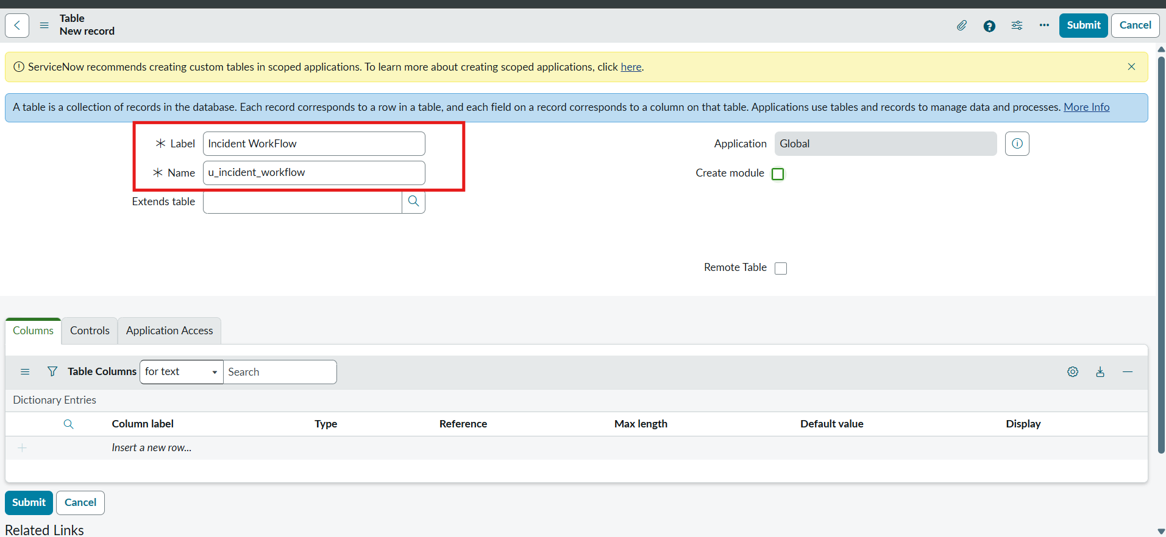
Custom table Incident WorkFlow (u_incident_workflow)
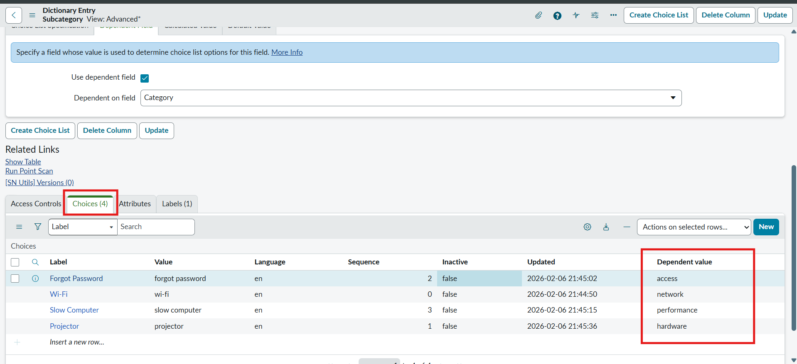
Dependent Category - Subcategory choices
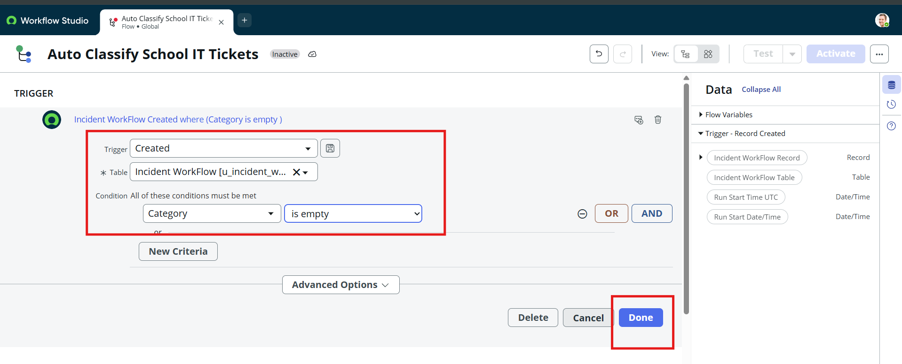
Flow trigger: Record Created, Category is empty
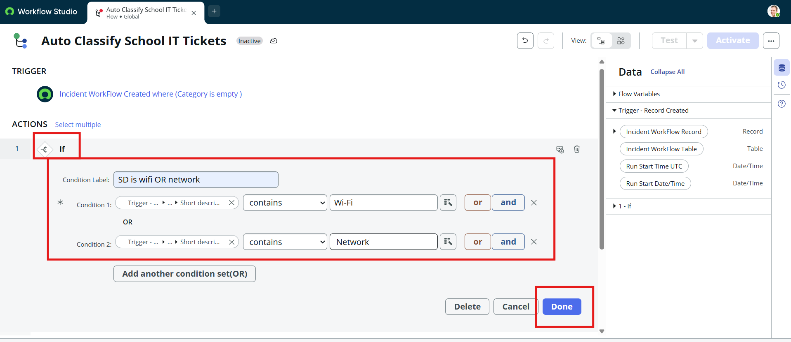
Wi-Fi / Network classification branch
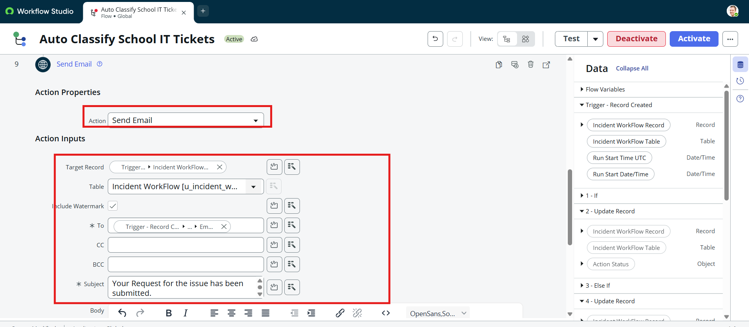
Send Email action to the caller
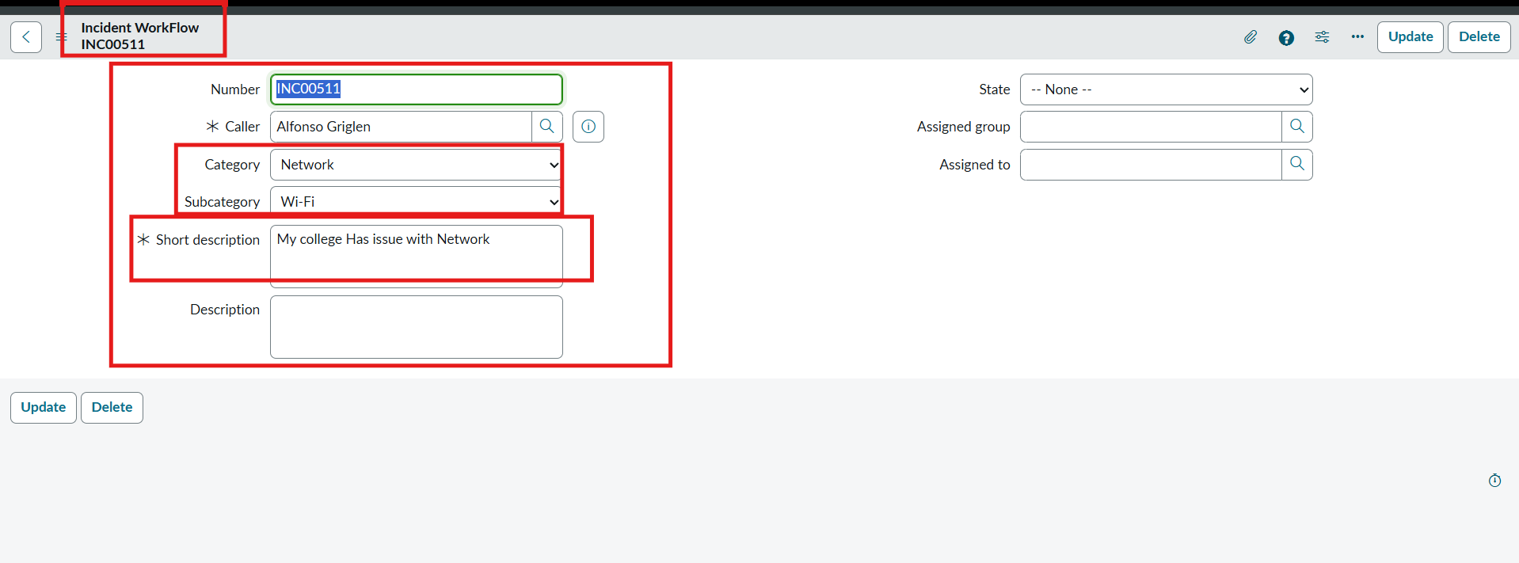
Test Scenario 1 - ticket auto-classified as Network / Wi-Fi
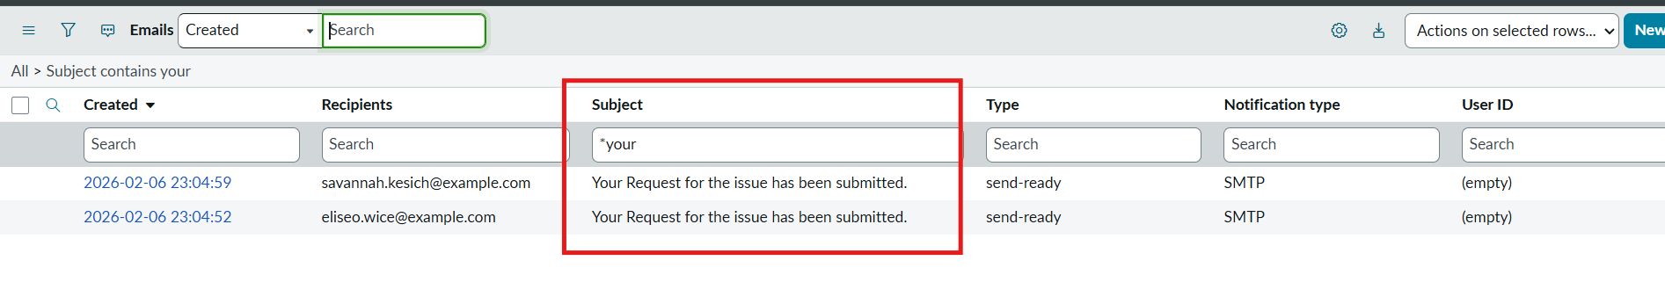
Confirmation emails in System Logs > Emails
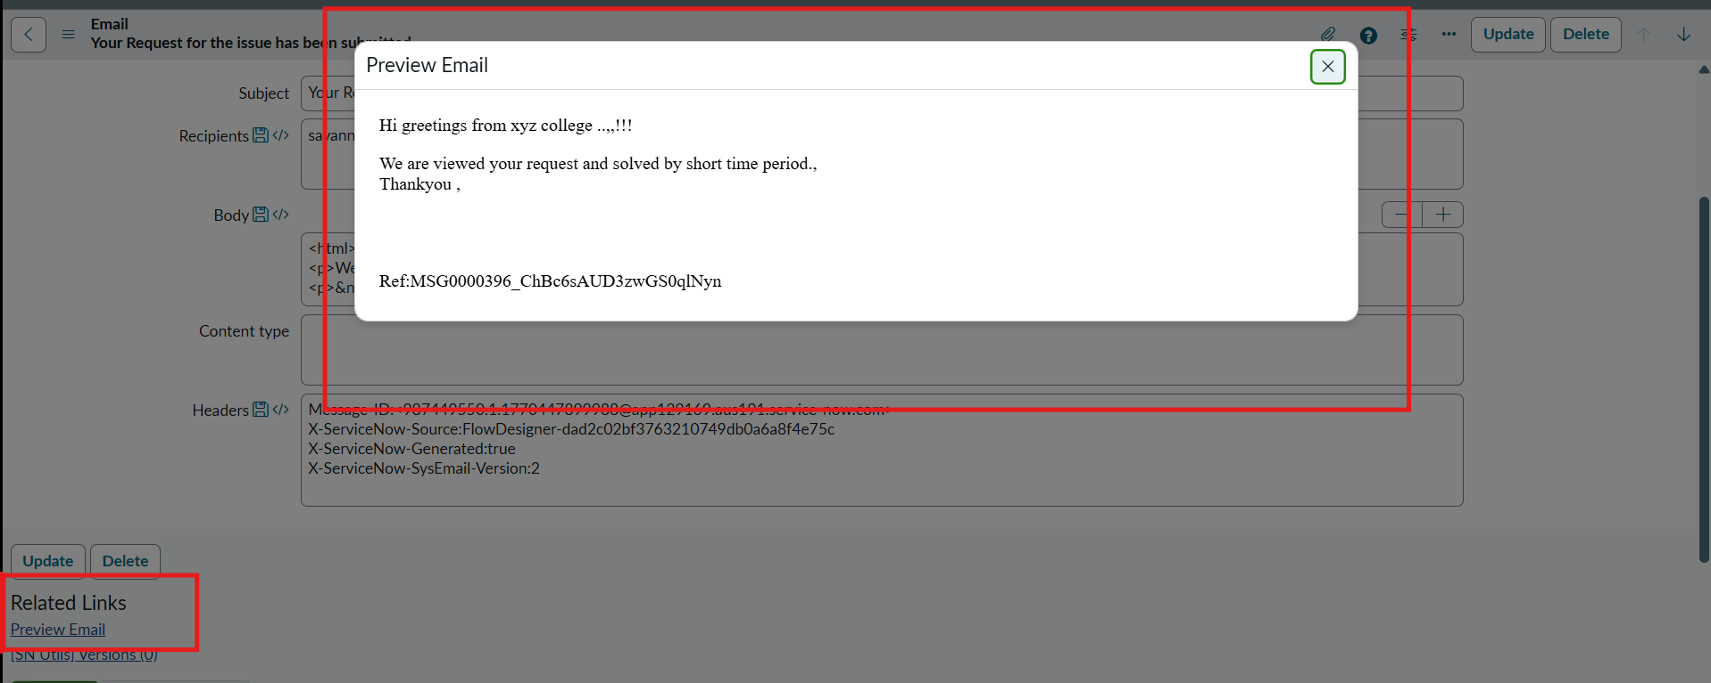
Email preview
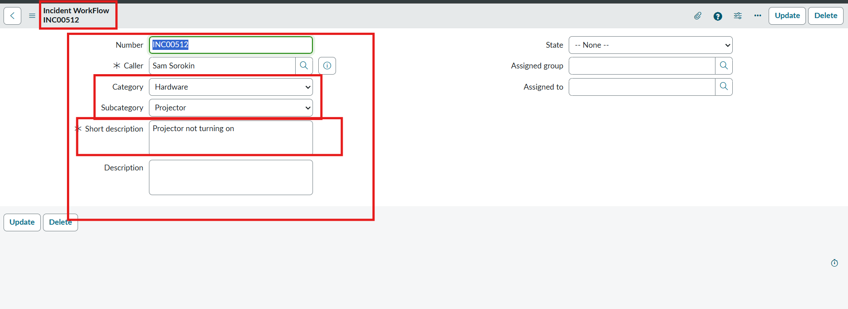
Test Scenario 2 - ticket auto-classified as Hardware / Projector
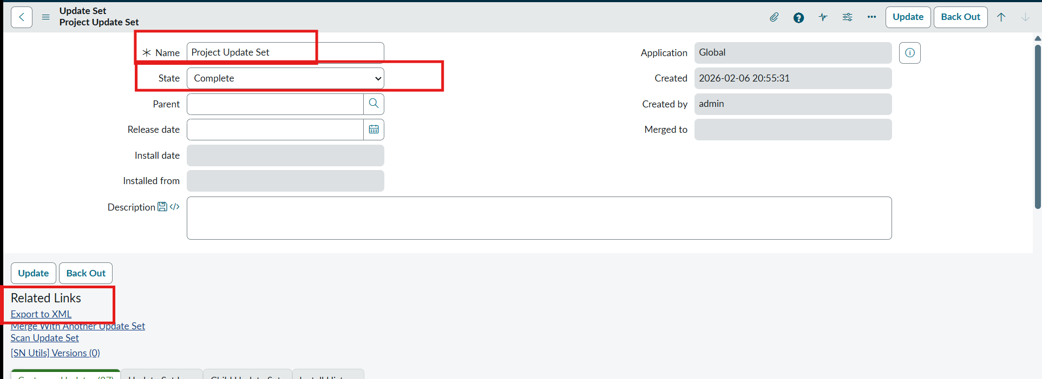
Project Update Set set to Complete
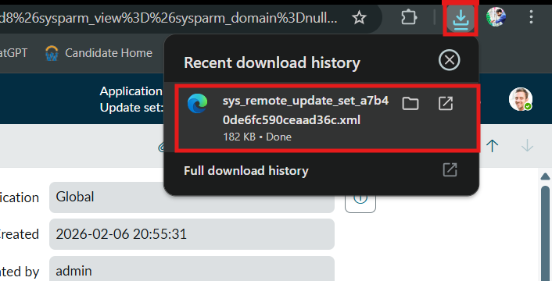
Update set exported as XML

8. Advantages & Disadvantages
Advantages
- Automatic classification at ticket creation removes manual triage.
- No-code: configured entirely in Flow Designer, easy to maintain.
- Consistent categories and standard data format.
- Caller gets an instant confirmation email.
- Easy to extend with new keywords or categories; portable through an update set.
Disadvantages
- Keyword matching is exact: variations such as 'WiFi' vs 'Wi-Fi' or unlisted words are not classified.
- Only four issue types are covered; other issues stay unclassified.
- No automatic assignment to groups or SLA handling yet.

9. Conclusion
The Auto Ticket Classification using Flow Designer project delivers an end-to-end automation solution for a school IT helpdesk. Through structured requirement analysis, careful backend configuration and no-code automation using Flow Designer, the system automatically classifies IT tickets from the short description provided by students. Dependent choice fields ensure data accuracy, and automated email notifications improve communication by acknowledging ticket creation to the caller.
The solution was developed in phases, with testing and security validation confirming reliable operation and data integrity. The design suits small to medium environments such as educational institutions and can be extended with assignment automation, SLA tracking or predictive intelligence.

10. Future Scope
- Automatically assign the Assignment group (and agent) based on category.
- Cover more keywords and variations (for example 'WiFi', 'login', 'hanging') and more issue types.
- SLA tracking, priority and escalation rules.
- Chatbot / Virtual Agent intake and SMS or Teams notifications.
- Predictive intelligence or an ML text classifier once enough ticket data exists.
- Dashboards and reports on ticket volume by category.

11. Appendix
Item | Details
Source Code | Not applicable - no-code solution built with Flow Designer. The configuration is in the exported update set 'Project Update Set' (sys_remote_update_set_a7b40de6fc590ceaad36c.xml).
Dataset Link | Not applicable - tickets are created in the ServiceNow table u_incident_workflow.
GitHub & Project Demo Link | [Add your GitHub repository / demo video link here]

